The Worm’s Voice

Summer 2016 Week 7

August 17 & 20

Red Wiggler's CSA Newsletter

Notes from the Field: With all of this heat, a predictable schedule is key. Each day we have been getting going in the field early and finishing the work in the field before lunch. The afternoons are spent under the tree processing storage onions. Tomatoes are harvest Mondays, Wednesdays and Fridays. Squash, zucchini, okra, eggplants and peppers are harvested once a week.
-Remember to clean your veggies!
-Join the CSA Facebook Group. Search: “Red Wiggler CSA” and request to join.
-Please do not bring dogs, on or off leash, to your pick-up.

IN THE SHARE
- Potatoes: Purple Viking or Red Norland or German Butterball
- sweet peppers/ eggplant/ squash/ zucchini/ eggplant/ onions/ Dragon Beans
- Red/ Heirloom tomatoes
- cherry tomatoes/ ground cherries/ tomatillos
- hot peppers

PICK-YOUR-OWN
RED:
Oregano, Anise Hyssop, Nasturtiums, Mint, Gomphrena, pickeling dill (blooms)

ORANGE: Basil (Amethyst, lemon, Eleanora) Celosia, Gomphrena, Cosmos, Statice, Sunflowers (limit 1), Calendula

BROWN:
Banana peppers, Fever few, Anise Hyssop, Coneflower, Borage, Bee Balm

PINK:
Gomphrena, Zinnias,

YELLOW:
Parsley, Salvia, Winter Savory, Sage, Gomphrena, Marigolds, Sunflowers, Borage

GREEN:
Dill, Cilantro

Individual Highlights:
Inside Story 2
Inside Story 3
Inside Story 4
Inside Story 5
Inside Story 6
Inside Story 7
Last Story 8

Special Interest Articles:

- Briefly highlight your point of interest here.
- Briefly highlight your point of interest here.
- Briefly highlight your point of interest here.

Last week we pulled out the first planting of tomato plants. Tomato plants get diseases easily so instead of adding the plants to the compost where the disease could spread, we load up the truck and take them to the dump. We prepped the soil and did the first daikon radish cover crop planting. The daikon’s are very cool- you will hear lots more about them as the months get colder.
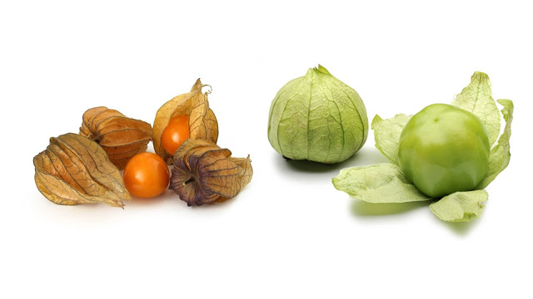
Lots of Tomatillos and Ground Cherries!: If you haven’t taken home a pint of one of these guys yet this summer, try one this week. Last week’s newsletter had recipes for salsas for both. This week’s potato salad taco recipe also calls for a tomatillo salsa.

Ground cherries can be used just like berries: eat raw, over yogurt or ice cream, add to a salad, or add to a peach crisp!
Looking for ground cherry recipes? They are also known as cape gooseberries and physalis.

Navigating THE TREE: One of the big locust shade trees at the entrance to the fields fell during the storm on Monday, blocking the entrance and some of the PYO.
We have created a temporary entrance to the field just up the driveway from the normal entrance- during pick-up today we will have a tent set-up just outside of it to make it easy to find.
If you have young ones coming to the pick-up, please be extra diligent in ensuring their safety and please do not climb on the fallen tree.
Hopefully it will get cleaned up quickly and things will be back to normal next week!
Herbs in the PYO: Please help yourself to lots of basil, sage, winter savory and parsley. If you can’t find something, just ask!

Recipes

Healthy Potato ‘Salad’ and Tomatillo Tacos by Martha Rose Shulman
Makes 12 tacos

1 ½ pounds potatoes scrubbed and
cut in 1/2-inch dice
2 tablespoons extra virgin olive oil, sunflower oil, grapeseed oil or canola oil
1 small red or white onion, quartered lengthwise, then cut across the grain in thin slices
1 teaspoon Mexican oregano or fresh thyme
1 garlic clove, minced
3 eggs, hard-boiled and chopped
1 cup quick fresh tomatillo salsa (see last week’s newsletter)
12 corn tortillas
About 1/4 cup chopped cilantro, plus more for garnish
3 ounces goat cheese or queso fresco, crumbled

Steam the potatoes above 1 inch of water for 10 minutes, or until tender. Remove the potatoes from the heat but don’t discard the steaming water.
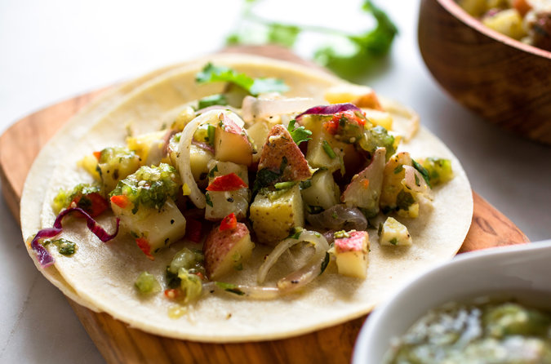
Heat the oil in a wide, heavy skillet over medium heat. Add the onion and cook, stirring, until tender, about 5 minutes. Add a generous pinch of salt and the potatoes and oregano or thyme, and continue to cook, stirring, for a few more minutes, until the onions begin to color on the edges. Add the garlic and stir until it begins to smell fragrant, about 30 seconds to a minute. Season to taste with salt and pepper. Remove from the heat and allow to cool for 5 minutes. Add 1/2 cup of the salsa and the cilantro and stir together.

Heat the tortillas. Wrap them in a kitchen towel and place in the steamer. Bring the water back to a boil, cover and steam 1 minute. Turn off the heat and allow the tortillas to sit undisturbed for 10 to 15 minutes.

Top the tortillas with the potato mixture and top the potatoes with another spoonful of salsa and some crumbled cheese. Garnish with more cilantro, fold the tortillas over and serve.

Quick Dilly Beans

1/4 cup chopped fresh dill
1/2 pound green beans, trimmed
1 cup white wine vinegar
1 cup water
2 teaspoons sugar
2 teaspoons salt
2 teaspoons pickling spice
1 garlic clove, peeled

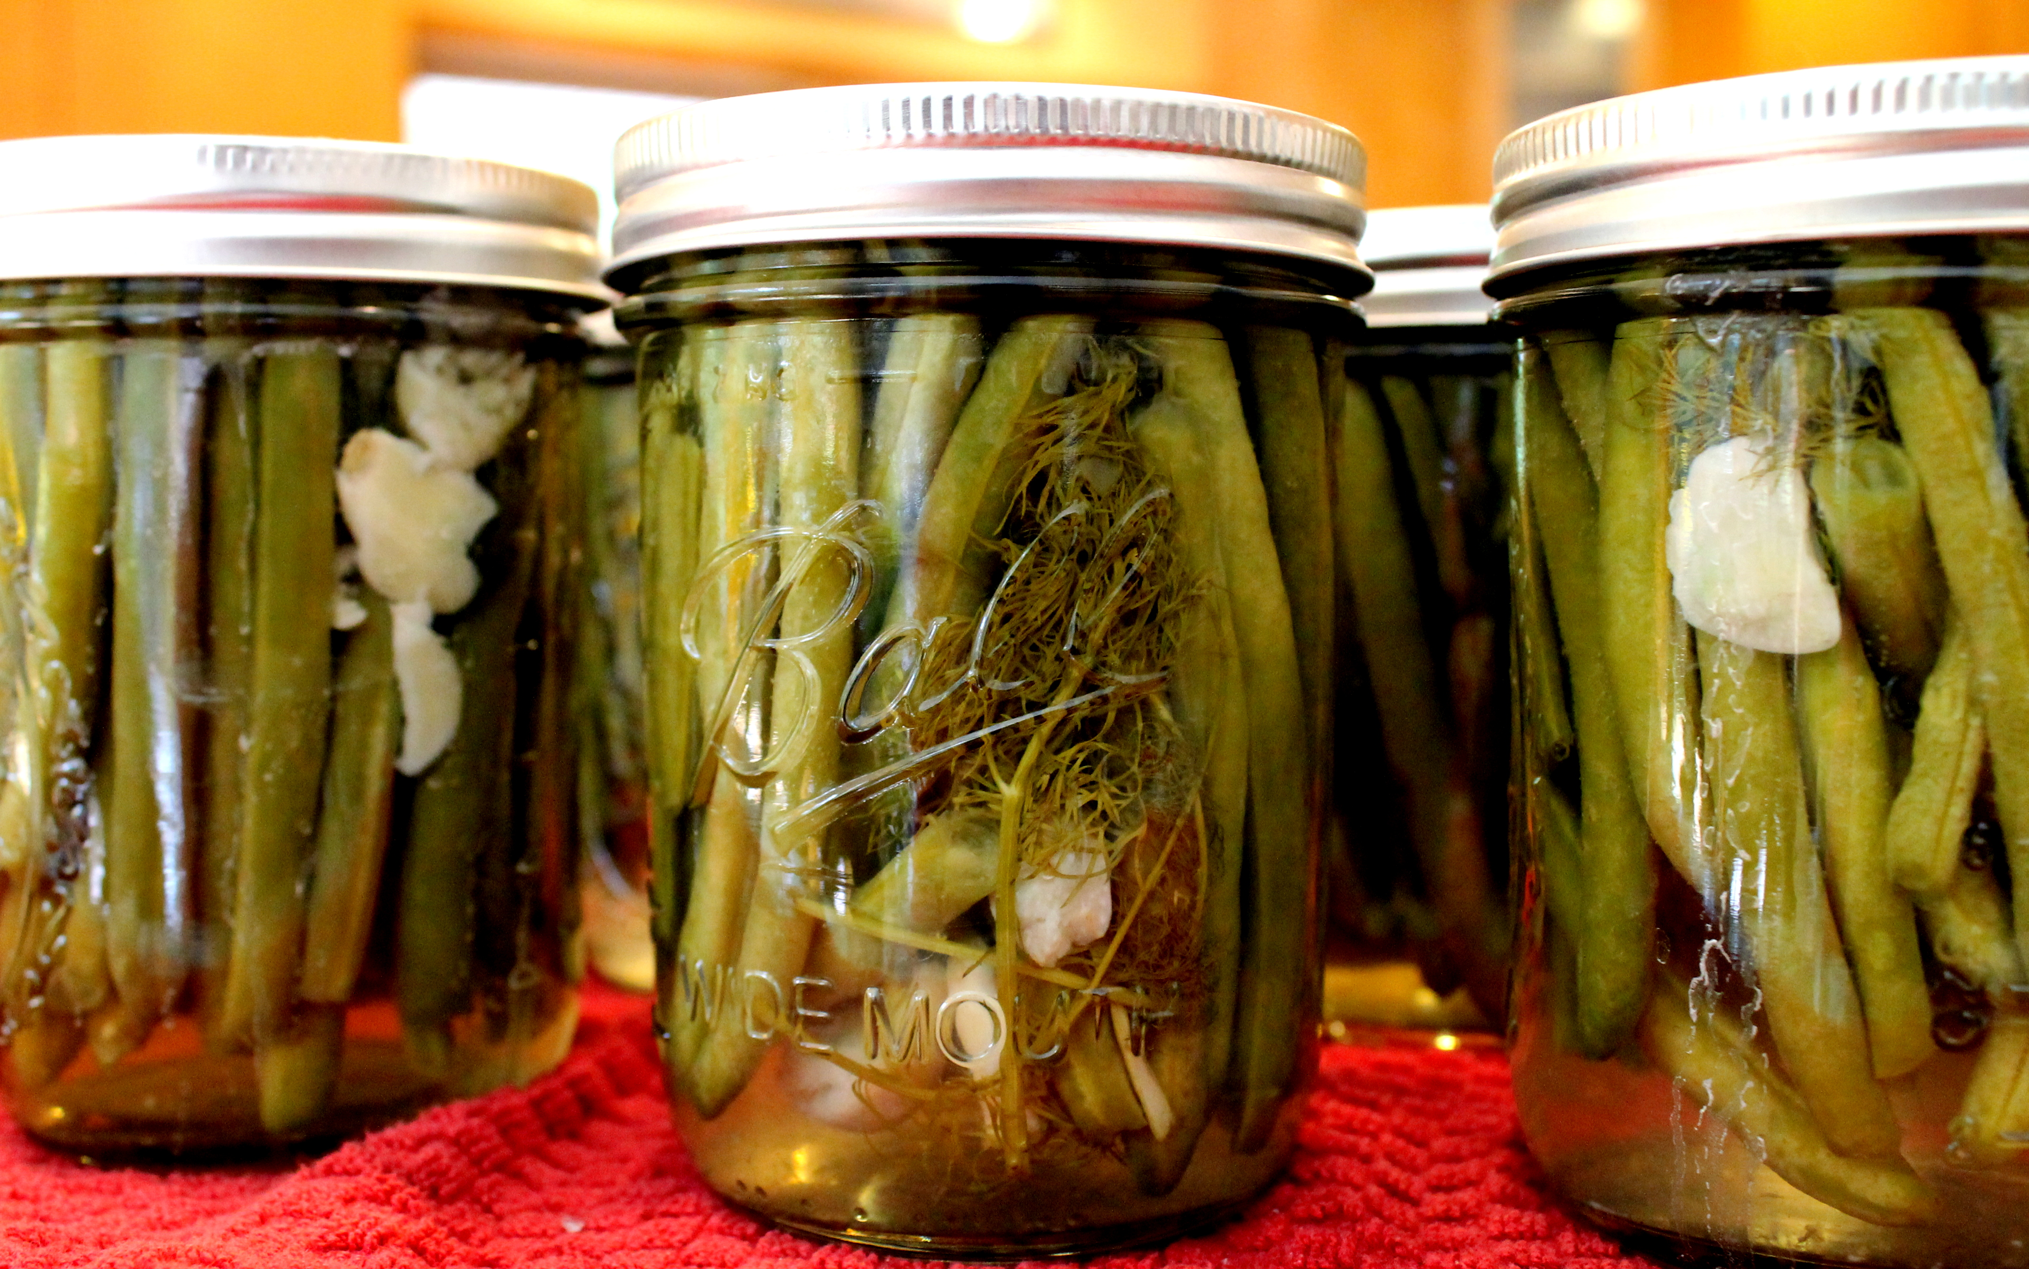
1. Combine dill and green beans in a medium bowl.
2. Combine vinegar and the remaining ingredients in a small saucepan. Bring to a boil, and cook 1 minute or until sugar and salt dissolve. Pour over bean mixture. Let stand 2 hours before serving. Will keep in the refrigerator for several weeks. *Bonus: Add a fish pepper or ½ a jalapeno for some spice.

